My Latest Foxhunting Adventure: A Cowboy in County Clare
By Barbara Smith
I had the great fortune recently to go hunting in County Clare, Ireland, with a group of fellow foxhunters from the western United States. Lynn Lloyd and Angela Murray, joint masters of Red Rock Hounds in Reno, Nevada were celebrating Lynn’s birthday with a trip to Ireland that their friends, Renee and Kail Mantle, from Big Sky Hounds in Three Forks, Montana, had been planning since last June. As well as members of these two hunts, they had rounded up foxhunters from Mission Valley Hunt Club, in Kansas, Bonnie Becker from Massbach Hounds in Illinois, some friends from Las Vegas and myself from Marlborough and Bull Run Hunt in Virginia. There were 24 of us ready to hunt over the stonewalls, hedges and banks of Western Ireland with three different hunts and other than Lynn and myself, it was the first time for the rest of them.
I had met Renee and Kail Mantle last year at Red Rock for the MFHA Pacific District meet. Kail had given us a bucking horse lesson one day before hunting and this Montana cowboy, who hunts in chaps and cowboy hat, had sat calmly to his horse bucking crazily above the sagebrush and had seriously impressed me. When they invited me to come to Ireland, I jumped at the chance. These were fun people; more than a little crazy and I wondered if anyone had warned the Irish! I also wondered if they knew what they were getting into, as I had hunted the big Irish walls and hedges in 2000. I came home with newfound respect for any one who hunts regularly in Ireland. It is challenging country and their version of foxhunting is an excuse to run and jump really big fences.
Renee Mantle had done an excellent job planning this trip with great care to the smallest detail. We stayed in a beautiful private estate, named Ceaparana, (www.ceaparana.com) in Puckuan, County Tipperary. I highly recommend this lovely home, which had at least 8 bedrooms and baths and was centrally located for the three different hunts, County Roscommon Hunt, the East Clare Harriers and the North Tipperary Hunt. Renee had contacted Oliver Walsh of Flowerhill Equestrian Centre in Ballinasloe, Co. Galway (www.flowerhill.net) to set up the horse livery for all 24 of us, for all 5 days of riding. He promised us great horses and managed to deliver on that promise. Oliver is also the huntsman for the County Roscommon Hunt. A tall, white-haired, charismatic Irish gentleman with an ease about himself that sets everyone else at ease also. To manage to arrive at a hunt with 20 livery horses and new riders 4 days in a row and hunt hounds as well, was a remarkable achievement. He has excellent help and his assistant, Keely, was a charming young woman who took great care of all of us. The horses were wonderful and I thought between them and Renee’ suggestions, they paired us all up with suitable mounts.
After one day to relax, recover and go sightseeing, on Friday morning we went to the Flowerhill Equestrian Centre, which also offers eventing and cross country training, to meet our horses and go for a trail ride. This was to give a few of the members of the group a chance to jump in a more controlled environment. He had set up small gymnastic jumping courses and everyone had a great time following his lead through some water obstacles, some streams and over the jumps. He grinned, offered simple advice like, “not too fast”, and then deemed everyone ready. He had set up an extra hunt for us with his hunt, County Roscommon, on Saturday, and then we would go with them again on their regular Sunday hunt.
But before hunting we were going Friday night to the County Roscommon Hunt Ball. Held at the Abbey Hotel in Roscommon, we planned to spend the night and hunt the next day from here. We had brought our evening dresses and tuxes and we were treated to a grand evening of dinner and dancing. It was very similar to our own hunt balls, though I wondered what some of our Irish hosts thought of this happy group of Americans that had descended on them. Oliver said we were the largest group he had ever had and we took over two long tables at the Ball. We started dancing early and, I heard, stayed to the very end! The evening wrapped up about 3 am with a rendition of the Irish National Anthem to which several Americans cheerily sang along!
We met the next morning at the local pub where we tried the hot port or hot whiskey as we waited for Oliver and the horses to arrive. In my experience all hunts in Ireland start at the pub and end in the pub! This was no exception and after two or three hot ports, the lorries arrived and we were off. Trotting through the town of Roscommon and down the highway, we turned off after several miles and watched as Oliver sent the hounds into the covert. Here the coverts are hedges and walls that separate the beautiful green fields and farms. We headed over the first of many rock walls and I glanced back, hoping the group was all together. There were a couple of loose horses and Oliver’s assistants were terrific at catching horses, reuniting them with riders and offering encouragement. Our group of Western riders were game for it all and quickly learned to just follow the horse in front and “kick on”. Some were able to find a more conservative route in the days that followed but most of us were jumping the walls and hedges in fine Irish form.
Kail Mantle from Montana was a natural and I guess a “bronc” rider who learns to throw his arm to counter balance a buck can do the same over 4 foot walls. Riding long, in his jeans and cowboy boots, with his foot all the way ‘”home” in the stirrup, Kail was right behind me over the biggest fences and by the third day was quietly heard to say, “This is kinda fun”! He was always looking out for the more timid rider and was the first to take charge of anybody who was over faced by a jump. He encouraged and took care of the whole group. I think he was also impressed by some of the wild Irish and their jumping abilities. Another natural who was a complete newcomer to the art of Irish hunting was Kurt Griffiths, the husband of Marie Griffiths, the joint master from Big Sky. Long and lanky, he sat relaxed on his big Irish Sport horse, “Celtic Man, a 17.2 hand chestnut with a big, roman nosed handsome head. They suited each other to a tee and Kurt just followed Celtic Man’s lead over everything.
The Irish like to lark a bit and would look for the biggest hedges and walls to school their steeplechasers over, whenever there was a lull in the hunting. I followed over several before realizing it was optional and decided that caution was sometimes a better idea. Lynn Lloyd and I agreed that with a certain age comes the desire to last for another day and to chose the gentler approach! Neither of us came a cropper much to our quiet delight.
That first day our huntsman Oliver Walsh, took a path very close to the nearby lake, to perhaps avoid a few big walls. Well, it turned into a scene from “Misty of Chincoteague”, as the farmer’s herd of Irish ponies happily jumped out of their pasture and followed the hunt. They proceeded to swim across the lake to an island and we all watched entranced. The only drawback was our horses were standing about chest deep in cold lake water as the field master looked to find a way out from this path along the edge. We then noticed a saddled horse swimming loose and realized the joint field master had come off in the water. Later we were to hear that this game woman had been asked by Oliver, “Since she was already in the water, could she take a few stones off the wall so we can get out!” I am sure the words spoken back at Oliver were as blue as she was from the cold as she sloshed out of the lake. Kail had seen the danger and joined by our field master Anthony, who had gone back to rescue his son on a small pony, found a way out through a gate, over two big walls and caught up in a few moments. The hounds had teetered and tottered along the rock wall trying to avoid going swimming themselves. The day ended with hot toddies and sandwiches offered by the landowner as we gathered in his front yard. Everyone was grinning and laughing about our adventure and greeting some old friends.
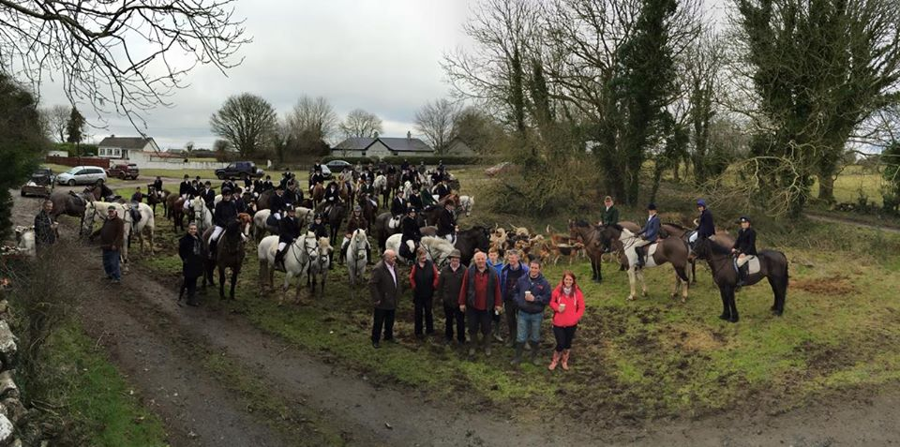
Photo by Val Westover
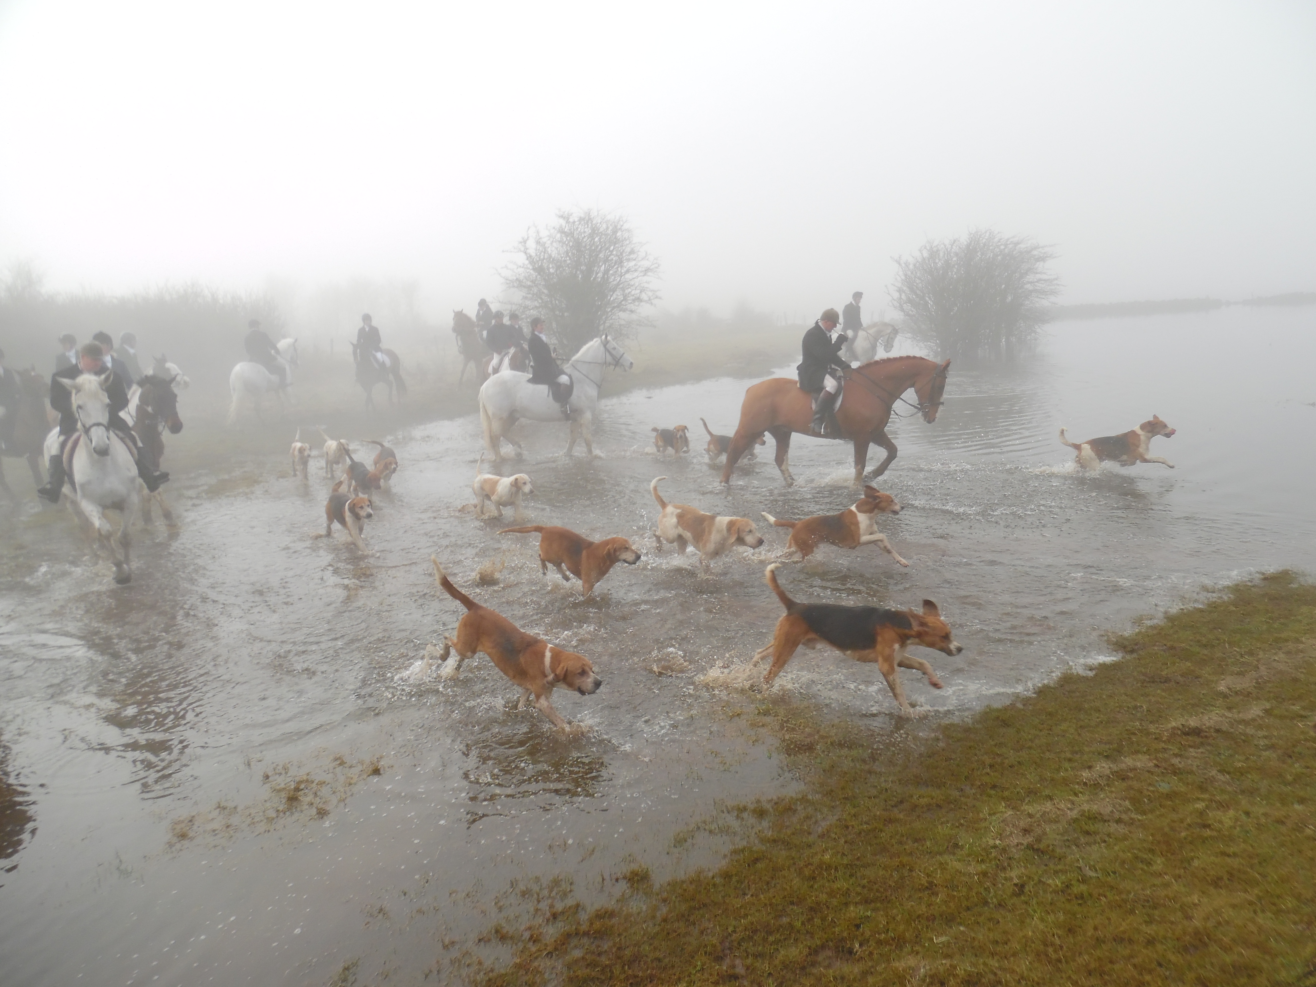

Sunday morning we headed north again to meet Oliver and his horses for another day with the County Roscommon hunt. This was a larger group of foxhunters and as I listened to the talk in the pub, I realized that Oliver Walsh was a very respected huntsman and people came from far away to hunt with him. He had apparently resurrected the County Roscommon Hunt after several years of no hunting and I met foxhunters from as far as Wicklow on the East coast who drove three hours every Sunday to hunt. I was introduced to several members of the Galway Blazers who regularly hunted here also. I ran into Johnny Geoghegan, a renowned Galway horseman, who had leased us our horses last time I was in Ireland in 2000. He happily followed Oliver and was one of the crazy Irish looking for the biggest hedge or wall to jump.
There were lots of these to jump and it was rockier than the previous day. I turned to snap a picture after one jump and was surprised to see a friend’s riderless horse coming on. Sara Tharp of Montana remembered landing over the wall, but then the next memory she laughingly recalled was of a large Irish gentleman asking if she could get up. Clutching a dislocated shoulder she said, “ No, she didn’t think so.” He replied, “Well, you can’t stay here, [they’ll jump on you], so you better get up!” And he unceremoniously hauled her up. Our only real riding casualty, Sara followed the next hunts with the professional photographers, Val and Stephanie Westover. (They have produced a beautiful museum quality album of our hunting trip available at www.valwestoverphotography.com). Unfortunately, Oliver also had a fall that day and shortly thereafter we came in, calling it a day.
Monday was another day to tour some of the Irish countryside. My group visited Clonmacnoise, a 8th Century monastery that had been the home of St. Ciaran, a beloved Irish Saint. After walking among the ancient tombstones, we spent the afternoon drinking Irish coffees with a Mr. Oliver Darcy in his family’s grocery store and pub in the tiny nearby village. On the drive home we found the DuBarry factory where several of us found great boots and coats at discount prices.
Tuesday we drove west around Lough (Lake) Derg to hunt with the East Clare Harriers. After one day of rest, most of us were reunited with our same horses and they were fit and ready to go. Trusting our mounts at this point, some of us were game to try to bigger walls and hedges. One trappy hedge had a big drop on the far side and I was happy to land in one piece, on my horse! Looking back I laughed to realize I was the only American to have tried this one. There had also been some banks and ditches at this point and only the daring Irish had flown over some of them, once or twice unsuccessfully, which they think is very funny. It was beautiful countryside, at one point we were on top of a mountain in a peat bog! Seemed strange to us to have soft, muddy going so high above the lake. The were fields of heather and then suddenly we were walking through a forested glen that was magical. Quiet and emerald green, it was misty and mossy and I expected to see a leprechaun at any moment.
Our huntsman, Shane, who with his two brothers Pat and David ran the East Clare Harriers, (the former was the field master and the latter was the President of the Hunt) told us their hounds were Modern English. Most were tri-color and had excellent conformation, very upright with compact feet and toes. There were also some Welsh hounds, tall with longer wiry coats. Apparently the addition of this Welsh bloodline was the reason for the “Modern English” name.
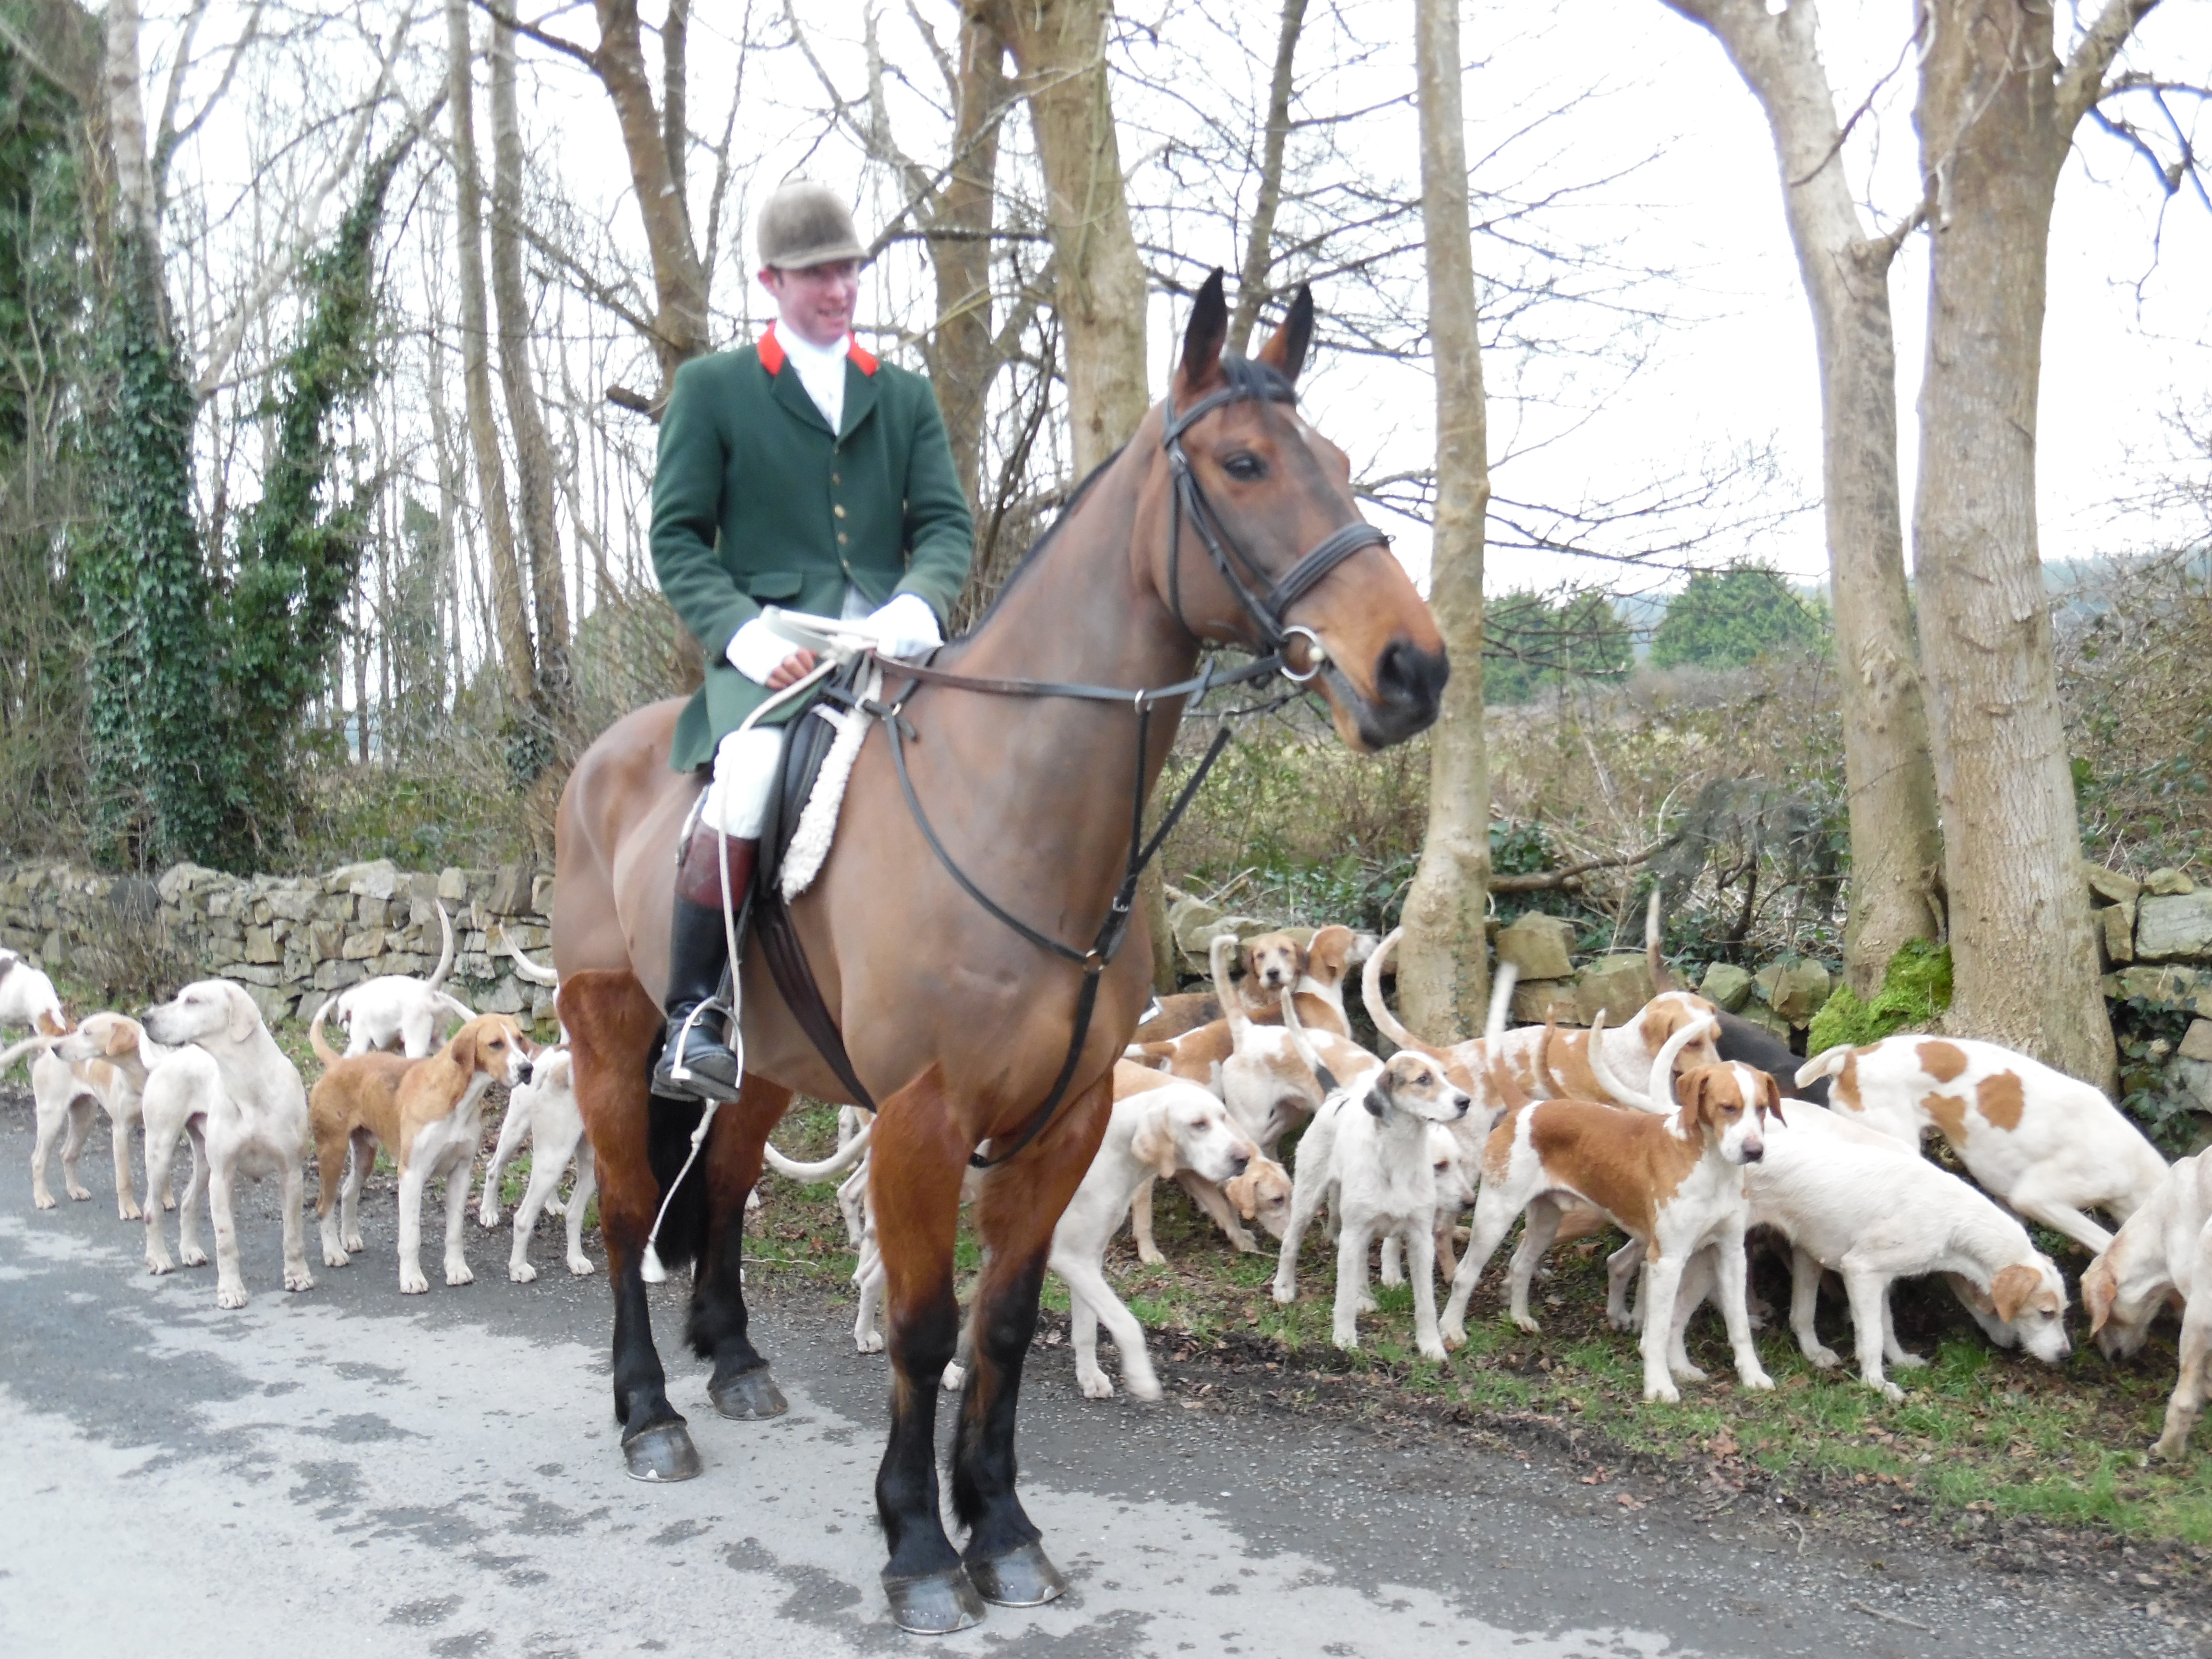
These hounds ran well all day and never stopped hunting. We had been having somewhat of a blank day until, on the way home, a fox jumped up right in front of the pack and they promptly accounted for him. It had been fun to watch some of the Irish children on their ponies. One pony had jumped a wall and just sat down, on the wall, until the small lad had berated him with a loud smack with his whip, which prompted the pony to jump down. These children seemed fearless and very smart. On one occasion I heard a small boy emphatically tell his Mum he was not going to take a trappy jump. He turned and galloped off and she shrugged, saying he knew his way about better than she did. A clue to avoid a bigger jump, follow the smallest child! We finished the day in the same pub where we started with hot port or whiskey and sandwiches. The hospitality had been wonderful at every place we had been, with the Irish locals delighted to share their stories and their Guinness’ with us at every opportunity.
The next day we hunted with North Tipperary Hunt and their pack of “Old English”. These hounds adored their huntsman. After every run, when their huntsman collected the pack, they patiently sat and never took their eyes off him.
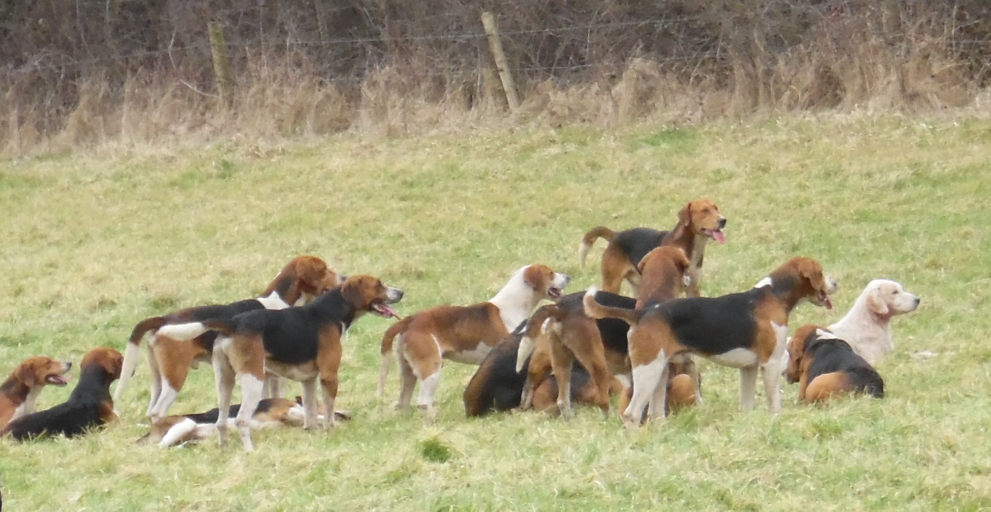
We had met as usual in the local pub and moved off into a nearby landowner’s field. The first trappy ditch stopped a few, but soon all managed to join the main body of riders as we moved across the beautiful fields of the next estate. A Thoroughbred breeding farm, the owners had pulled all the broodmares in for our hunt and we were treated to a lovely day of walls and ditches. The visiting Americans opted out of most of the ditches, which looked very tricky. We watched as the Irish laughed at each other’s occasional dunkings in the deep water-filled ditches. Jodee Renee of Red Rock Hounds had followed the huntsman at one point and learned the one sure way to get over a difficult ditch. Let the horse go first and follow on foot!! One young Irish girl was completely drenched and looking a little worse the wear after her horse had gone in the ditch too.
We were starting to trust our wonderful Irish horses and the prelude to this ditch experience had been jumping a five-bar gate. I had always wanted to say I had jumped one of these large gates, so after the huntsman cleared it, I just “kicked on”. One of the other girls followed me and we galloped after the huntsman into some very thick brush. In moments he returned, saying the hounds were heading back. I turned with him, whispering to my cohort to wait until someone kindly moved the same 5-bar gate to lean away from us. The huntsman was too keen to wait and took the gate at a flying gallop. His horse promptly somersaulted as it hit the gate, which was still leaning in our direction. He flipped out of the saddle and landed face first in the soft Irish turf. Both jumped up and he had remounted after a quick once–over and was quickly off after hounds. Luckily for us, the gate was now leaning in the right direction to safely jump back! It had been a long day and the hounds had split. The hunt staff were going in two different directions and we could hear both groups still speaking. We decided to join the riders going in and the thought of hot port and sandwiches was most welcome.
Thursday was a day off and many of us went to the Cliffs of Moher to see the spectacular west coast of County Clare. Some went east to visit the Irish National Stud and all of us looked for gifts to take home. I simply walked into the Blarney Woolen Store opposite Bunratty Castle and ordered seven beautiful Irish cable knit sweaters and thankfully shipping home was free!
Thursday evening we visited our favorite pub “Larkins” in Garrykennedy, County Tipperary, to celebrate Lynn Lloyd’s birthday. Shar, one of our ladies who lives in Las Vegas and knows the inside of a bar (remember “Cocktail”) decided to teach the Irish lads a thing or two about making Vegas shooters. Many Guinness’ and Irish cocktails later we were thanking the owners for their generosity and wonderful hospitality. They encouraged us to come back and bring lots of friends. Between the excellent food like fish and chips and grilled salmon and seafood chowders to mention a few dishes, we promised to give high praise at home and encourage our fellow foxhunters to come to Ireland.
Oliver Walsh of Flowerhill Equestrian Center supplied us with wonderful horses for the week. They were excellent jumpers and easy to rate for the less experienced. All of the hunts were welcoming and worked very hard to give their American guests an excellent taste of Irish foxhunting. I can not wait to go again. Thank you Renee for an excellent adventure.
All other photos by Barbara Smith

